**MIST AUTOMATED ATTENDANCE SYSTEM (MAAS)**

Group no- 5

A. H. M. Zobyer(201714013)

Farzana Faruk Jhumu(201714023)

Masrur Hasan Mahin(201714027)

Ariful Islam Tarek(201714013)

Nafiz Imtiaz Khan(201714043)

Sumaiya Nuha Mustafina(201714059)

**Abstract**

The aim of the project is to ensure attendance automatically by using bio-metric (fingerprint) technology. Before entering into a class student will complete fool-proof bio-metric verification which will mark them present in the attendance sheet automatically. So this will save time wasted in calling out names. A web based platform is used on this project where a teacher and students can see the attendance record (percentage, fine, eligibility for exam etc.) from this platform based on accessibility. Proxy, skipping classes & late coming will be handled using sensors so it will keep track of the valid attendance records.

**Introduction**

Attendance record means a summary of the pupil's attendance during the period to which the information relates, showing the total number of possible attendances and the total number of unauthorized absences. Nowadays attendance is ensured by calling out the names which is more time consuming. Moreover sometimes it is tough for a teacher to prevent proxy and identify whether someone is entering late in the classroom or leaving the class before the finishing time. Automatic attendance system will ensure attendance each time a class starts and proxy is impossible as the attendance will count through biometric verification. Teacher is authorized to edit the attendance. So this platform will handle attendance related task automatically after ending of each class and total attendance record after each term for the teacher and as well as for students which will decrease attendance related complexity.

**Objectives**

Objectives to be achieved from MAAS:

(1) To ensure maximum secure attendance by biometrics technology.

(2) To make it easy for both students and teachers to know about their attendance.

(3) To reduce late coming tendency.

(4) To reduce the trouble of manual application system for leave.

(5) To reduce wastage of time during manual roll calling system.

Falls upon

Retrieve Data Send Data

**Database**

Data (Fingerprint, Roll etc.)

Output

Fingerprint match ()

Send data()

Detects if anyone passes by change of resister value

NodeMCU ESP8266 Arduino

LCD Display

**Microcontroller and other components**

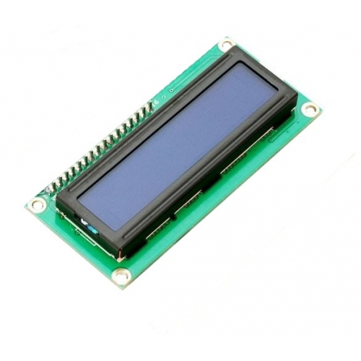 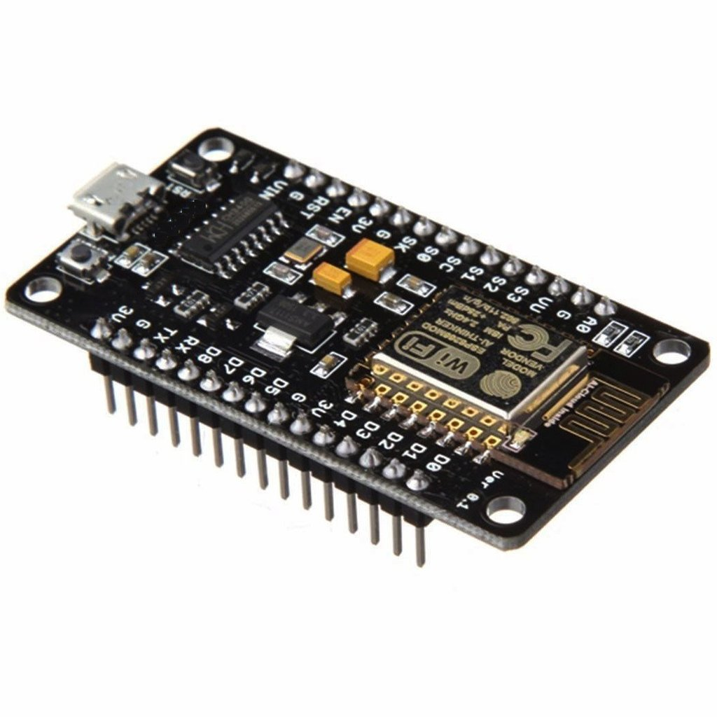

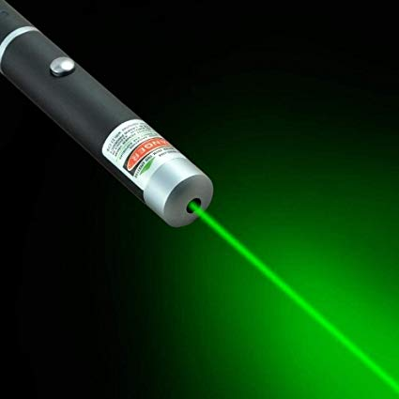 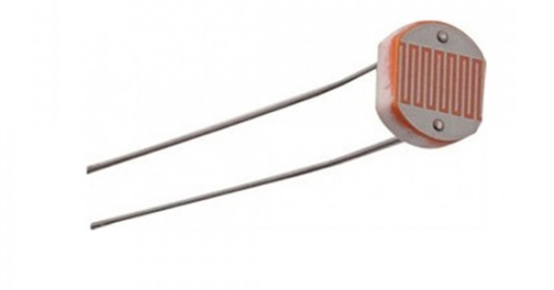 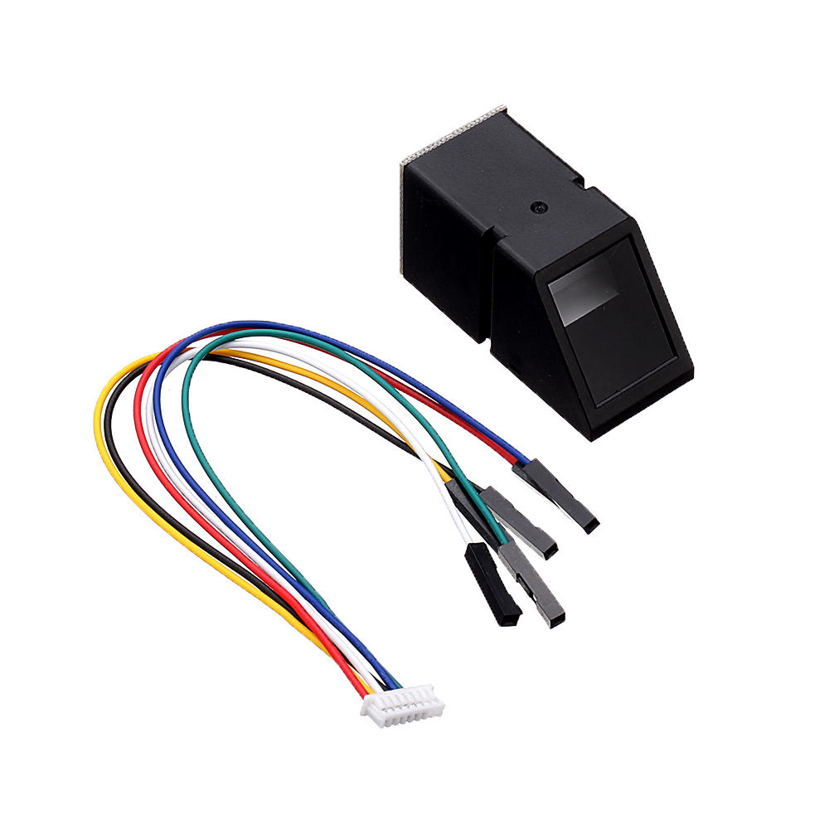

**Sensors**

Laser light

Fingerprint Scanner AS608

LDR



**Panels**



* Admin
* Teachers
* Students

**Workflow**

**Workflow**

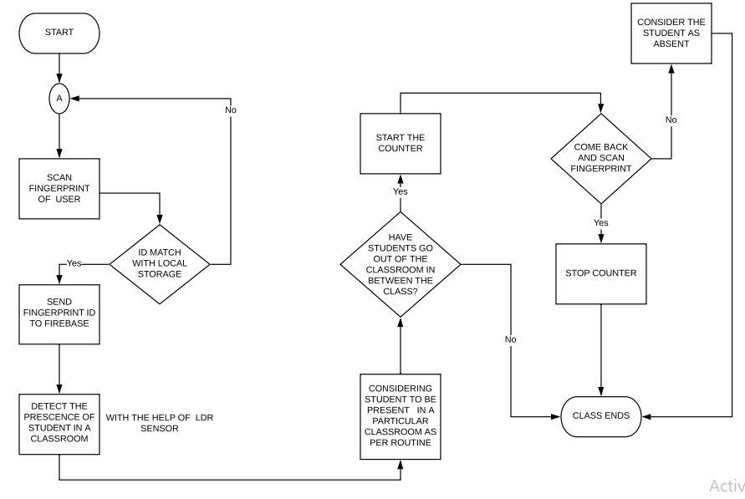

**Fig 1: Workflow of MAAS**

**Cost Analysis**

|  |  |  |
| --- | --- | --- |
| Ser. No | Items | Cost |
| 1 | Cost of Equipment | 6700 |
| 2 | Field Work | 500 |
| 3 | Typing, Drafting Binding & paper etc. | 1000 |
| Total Amount | | 8200 |

**Discussion**

The system stated above is being implemented with the help of fingerprint sensor. The previous system were more based on RFID and some implementation in some corporate offices. In spite of having an existing system the new system differ to the previous systems. In previous system there were major lack of a person needed to be present on the spot physically. Again, time taken by previous systems were more than the new one.

Now, Mist Automated Attendance System (MAAS) is more precise and accurate with the attendance regarding the previous systems. The new feature of MAAS is online application system for any fine purpose regarding Non Collegiate or Dis Collegiate. The toll on the teacher side is being reduced with help of the system .MAAS system also provide the irregular students of a class and take some actions against them. Firstly, it seemed quite easy to handle everything of a system but more implementation the flaws started to pop out. In the beginning connection of fingerprint and it’s matching with data stored was being tested with failed cases but eventually the accuracy began move in the positive direction. Then LDR (Light Dependent Resistor) was implemented for helping to get the attendance alongside a laser light. The data were far away from the desired output but with time the data are now more relevant and accurate. The system had to handle more failures on exception handling cases .Now it is more reliable. The major flaw of system is handling the students who are going out in middle of the class due to any purpose and also the students skipping the class time. Again Fingerprint stored is locally not global.

Despite of all these, we have come to a solution for handling this problems. The accuracy and time is more efficient in MAAS system than any other system. The features are more sophisticated than previous ones.

**Conclusion**

Mist Automated Attendance System (MAAS) can be more generalized for making an Automated Attendance System. MAAS provides flexibility to the stakeholder’s preference. It also minimizes physical report and handling cases affiliated to the institution. The system is more transparent on any side of user. As per implementation of the system we will be preferring MAAS should be easily applicable for any institution

**Future Expansion**

The future extent of MAAS is to implement door locking system along with automated attendance. The minor cases of failures and errors handling encountered in the system. The major setback will be handling door lock for the system and more global implementation.

**References:**

[1] “How fingerprint scanners work - optical, capacitive, and other variants”. [Online]. Available: <https://www.androidauthority.com/how-fingerprint-scanners-work-670934/>.

[2]“Student Scheduling & Logistics Software Solutions”. [Online]. Available: https://www.schoolpass.com/product-tour/.

[4] Clavereau, M. (2011). Absence: time to tackle the root causes. Retrieved 15th October, 2013 from http://www.hrmagazine.co.uk Dale, M. R. (2005). A Process for Combining Structured Analysis and Object Oriented Design. Retrieved 10th February, 2013 from

[5] http://www.dtic.mil/ndia/systems/Rickman2.pdf. Dan, P. and Neil, P. (2005). UML 2.0 in a Nutshell. O'Reilly publication. ISBN: 0-596-00795-7. Dubin, C. (2011). "Biometrics: Hands Down, ID Management". Retrieved 30th March 2013 from

[6].http://proquest.umi.com/pqdweb?index=0&did=2277161341&SrchMode=1&sid=2&Fmt=6VInst=PROD&VTy pe=PQD&RQT=309&VName=PQD&TS=1304030671&clientId=13314. Hong, L., Wan, Y., and Jain, A. (1998). Fingerprint Image Enhancement algorithm and performance evaluation, Computer

[7] Journal of IEEE transactions pattern annulus machine intelligent, 20(8), pp. 777-789. Jianjiang, F. (2007). Combining minutiae descriptors for fingerprint matching, Pattern Recognition, pp. 342 – 352. Kadry, S. and Smaili, M. (2010). Wireless Attendance Management System Based on Iris Recognition. Scientific research essay. Retrieved 12th November, 2012 Kreimer, S. (2011). Matching the Right Patient to the right Record. Hospitals & Health Networks. Retrieved 12th November, 2012 from http://proquest. umi.

[8] http://www.smartcardalliance.org. Wayman, J. L., Jain, A. K., Maltoni, D., and Maio, D. (2005). Biometric Systems: Technology, Design and Performance Evaluation, New York: Springer Verlag. Yuihotakaishi (2011). Attendance Monitoring System Using Biometrics for Security Staff, studymode Inspiring.

[9] “Arduino Cookbook, 2nd Edition - O’Reilly Media”. [Online]. Available: <http://shop.oreilly.com/product/0636920022244.do>

[10] “Send Sensor Data to Firebase Real-Time Database - Hackster.io”. [Online]. Available: https://www.hackster.io/varuldcube100/send-sensor-data-to-firebase-real-time-database-4d6b83. [Accessed: 09-Oct.-2019].